Spike: Spike 36
Title: Input Handling

Author: Rachel McQueenie 696737x

Goals / deliverables:
- Spike report
- Simple console application using SDL that captures keyboard events and displays informative messages as text. Must demonstrate:
  - When a specific alpha key (a-z) is pressed (down) or released (up)
  - A keyboard state model that keeps track of all the current key states for number keys (1, 2, etc).

Technologies, Tools, and Resources used:
- Windows 7 / 8
- Visual Studio Professional 2012 / Ultimate 2012
- SDL 1.2 to 2.0 Migration Guide
  - http://wiki.libsdl.org/MigrationGuide
- StackOverflow: SDL_PollEvent Not Triggering
  - http://stackoverflow.com/questions/13205379/sdl-pollevent-not-triggering
- SDL 2 Documentation: SDL Keycode
  - http://wiki.libsdl.org/SDL_Keycode
- Lazyfoo – SDL 2.0 Lesson 4: Key Presses
  - http://lazyfoo.net/tutorials/SDL/04_key_presses/index.php

Tasks undertaken:
- Set up the variables needed for application.
  - loop is for the game loop
  - e is the event that will be fired (keypresses)
  - keyStates is used to record whether a key is pressed or not. The first dimension determines which numerical key it is (0-9), and the second is whether it is pressed or not (0 for no, 1 for yes).
- Initialise SDL and a window, as they are needed for Event Polling.
- Start the game loop and event loop
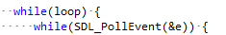
- Check if the application has been quit (such as from the 'x' button)
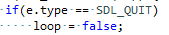
- Check if a key has been pressed
- Check if the 'a' key has been pressed. If so, display a message saying so.
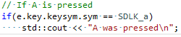
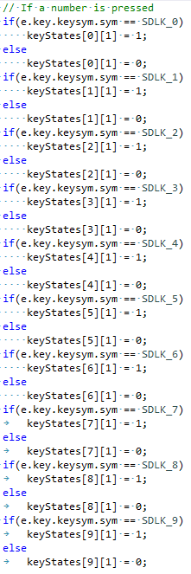
- Check if any number of numerical keys has been pressed. Record if it isn't pressed either, in case a key has been lifted up.

- Display which numerical keys were pressed. This is as simple as using std::cout to print to the console.
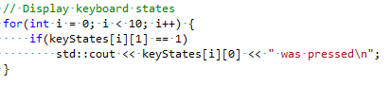
- Return 0 to exit the program
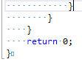

What we found out:
- How to poll events using SDL commands
- How to check for multiple key presses using SDL
- Use these keyboard events to display information by using if statements to check for the key presses and std::cout to print text to the console

Recommendations:
- Always make sure to initialise SDL and a screen, as depicted in Step 2. It is not made clear by a number of tutorials, but these are actually required for events to work so do not forget them.

